Climate Change data analysis based on World Bank data

**Student Name: Rizwan Mustafa**

**Repository Link:**  [**https://github.com/Rizwan354/Assignment-2**](https://github.com/Rizwan354/Assignment-2)

**Abstract:**

Climate change is a global issue which is affecting every nation on Earth. This report presents statistical analysis of selected climate change indicators for BRICS group countries and explores the potential correlations between them. The objective is to better understand the trends and relationships between these indicators and to provide a foundation for further analysis.

For this analysis BRICS Group countries were selected and the interrelations of the following factors on climate change were investigated: Energy use (kg of oil equivalent per capita), Electric power consumption (kWh per capita), Access to electricity (% of population), Renewable energy consumption (% of total final energy consumption).

The analysis found some correlations between the factors and causes behind them were investigated.

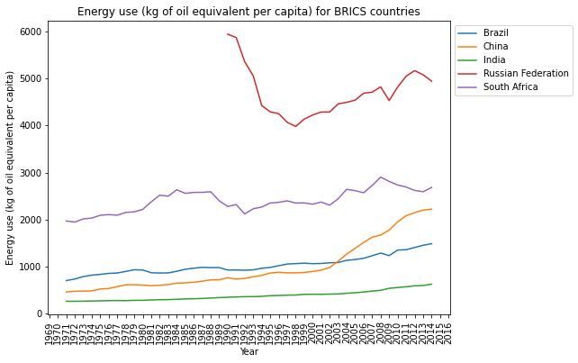 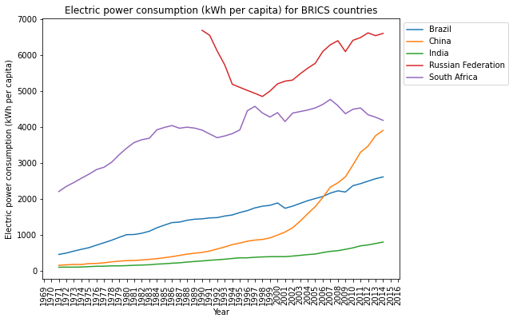

The line graph above on “Energy Use Per Capita” by the BRICS countries was constructed with available data from the year 1969 to 2016.

From above graph we can see that Russia has the highest Energy use per capita While India has the lowest Energy use per capita. Significant thing to note is that China is showing an upward trend in Energy use per capita with accelerated rates from 2003 onwards

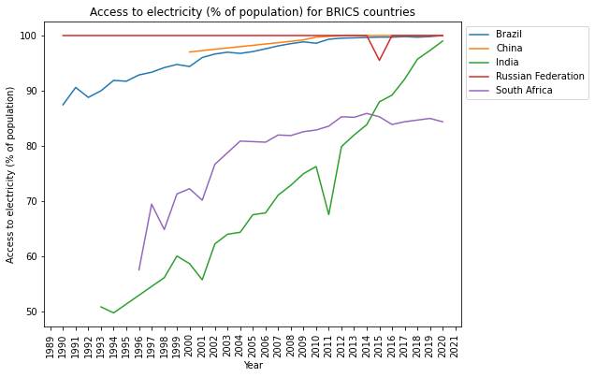

The graph here shows the “Access to Electricity (% of Population)”. Almost all the countries have positive trend in this respect. China and Russia and Brazil have the highest Access to Electricity almost 100%.

The above graph shows the “Electrical Power Consumption Per Capita” for BRICS Countries.

From above graph we can see that all the countries have upward trends in Electrical Power Consumption, only South Africa has negative trend. Just like we saw in the “Energy Use” graph on left side China is showing an upward trend in Electrical Power Consumption Per Capita with accelerated rates from 2000 onwards. And Russia has the Highest Electrical Power Consumption Per Capita.

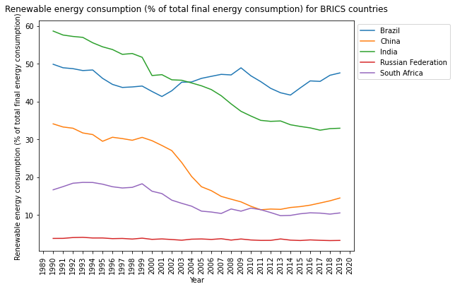

The graph here shows the “Renewable Energy Consumption. Brazil has the highest % of Renewable energy consumption while Russia has the least % of Renewable Energy Consumption. Also, almost all the countries have negative trend in this respect.

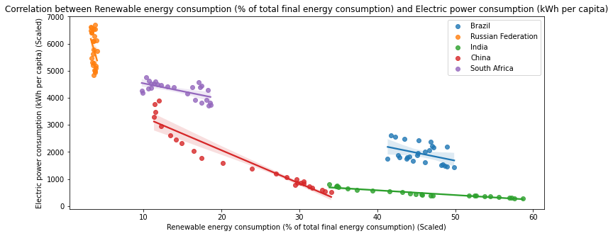 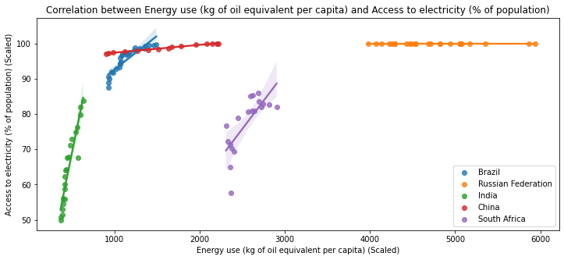

Also, I made regression plots to check the correlation between different indicators of countries. Those plots can be seen above.

From the plot above we can see that for all the countries, there seems to be a negative correlation between “Electrical Power Consumption Per Capita” and “Renewable Energy Consumption” population growth and CO2 emissions. This indicates that as the Electrical Power Consumption Per Capita increases, Renewable Energy Consumption tend to Decrease.

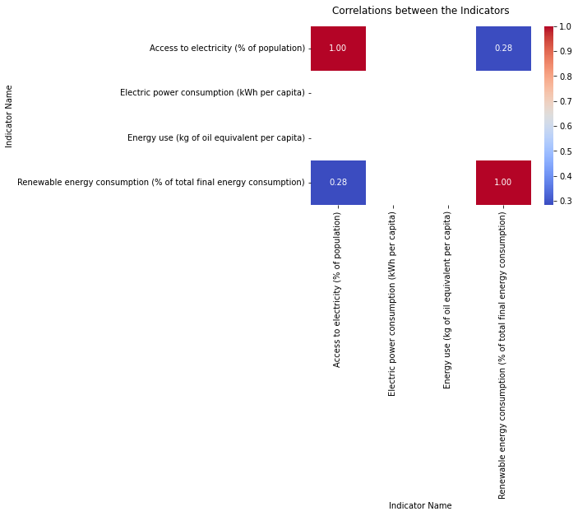

The plot highlights positive correlations between Access to Electricity and Renewable Energy Consumption, indicating that these variables tend to increase or decrease together. This suggests that as the Access to electricity increase, Renewable Energy Consumption also increase

Similar to the case of “Access to Electricity (% of Population)” and “Energy use (Per Capita)”, the relationship remains same among all the countries. In the case of energy use, the regression line is upwards that shows the positive relationship between the Energy use and Access to Electricity. This means that as the % of population which has the electricity increased, Energy use per Capita also increased.

From all the above observations we can conclude that the relationships between Energy use (kg of oil equivalent per capita), Electric power consumption (kWh per capita), Access to electricity (% of population), Renewable energy consumption (% of total final energy consumption) are almost same complex and can slightly vary among countries. But we cannot say that there is a universal trend. So, understanding the factors driving these correlations requires a deeper analysis.